**Assignment 2 – Prototype**

**Instructions Manual:**

We have used HTML and CSS for the web page User Interface. Routers and Controllers are implemented using the call back function and the web page is dynamically generated. The key functionality of our project, Analyzing “weekly sales by stores” is done with tableau.

**Folder Structure:**

|  |  |
| --- | --- |
| **Folder name** | **Details** |
| App-server 🡪 routes | Includes router code |
| App-server 🡪 Controllers | Includes Controller Codes |
| Public | Includes html, css and image files and html forms |
| Dynamic Page generation | Included in controllers as call back function |
| Key Functionality | Analysis of weekly data by store |

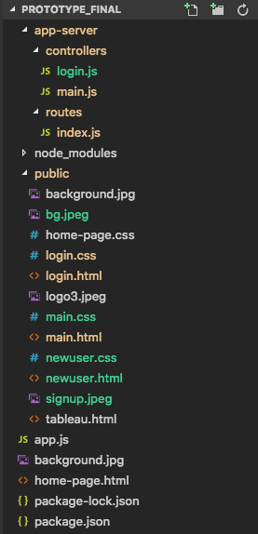

**Execution Details:**

To run the application, we require the following already installed,

1. Install express
2. Install node
3. Install line-reader
4. Install express-session
5. Install nodemon (optional)

**To Execute:**

Type nodemon appjs

Application launches at port 3000, localhost:3000

**Path1**: Click on Log In 🡪 Enter Username : u & Password: p 🡪 Click on Weekly analysis by Stores

**Path2**: Click on Log In 🡪 Don’t have an account 🡪 Emplyee ID: 123, Username:u & password: p 🡪 Click on weekly analysis by Stores

**Home Page:**

The home page of our application consists of basic information like, login, contact us, About US News etc

**Login Page:**

When user clicks on to Login, login credentials are requested form the users, new users can create a new user login.

Our login details are hardcoded for as username: ‘m’ password:’p’. Validation is provided a different username and password is entered

**Application:**

User can now sign-in to the application and select any one of the Analysis types,

Weekly Sales by store, Weekly sales by dept, Monthly Data analysis, Report.

Click on Weekly Sales by Store to view the weekly sales analysis for walmart.